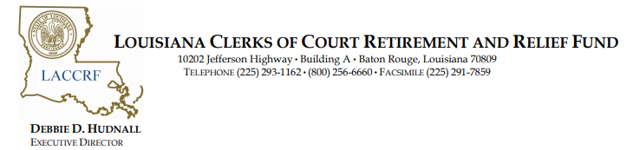

MEETING NOTICE
Louisiana Clerks of Court Retirement and Relief Fund
Board of Trustees Meeting
December 3, 2025
9:00 am
Golden Nugget Lake Charles
2550 Golden Nugget Boulevard
Lake Charles, LA 70601
Please visit www.laclerksofcourt.org for additional information.

